FORENSIC DENTAL X-RAY ENHANCEMENT USING CLAHE AND FAG TO DETERMINE AGE AND GENDER

A PROJECT REPORT

Submitted by

DAHLIA RANE P [211418104042]

KAVYA V R [211418104116]
NANDHINI S [211418104169]

in partial fulfillment for the award of the degree
of
BACHELOR OF ENGINEERING

in

COMPUTER SCIENCE AND ENGINEERING


PANIMALAR ENGINEERING COLLEGE
(An Autonomous Institution, Affiliated to Anna University, Chennai)

MAY 2022

PANIMALAR ENGINEERING COLLEGE

(An Autonomous Institution, Affiliated to Anna University, Chennai)

BONAFIDE CERTIFICATE

Certified that this project report “FORENSIC DENTAL X-RAY IMAGE ENHANCEMENT USING CLAHE AND FAG TO DETERMINE AGE AND GENDER” is the bonafide work of DAHLIA RANE P [211418104042], KAVYA V R [211418104116], NANDHINI S [211418104169] who carried out the project work under MRS.P. DEEPA, M.E supervision.

SIGNATURE SIGNATURE

Dr.S.MURUGAVALLI,M.E.,Ph.D.., MRS.P.DEEPA,M.E
HEAD OF THE DEPARTMENT SUPERVISOR
ASSOCIATE PROFESSOR

DEPARTMENT OF CSE, DEPARTMENT OF CSE,
PANIMALAR ENGINEERING COLLEGE, PANIMALAR ENGINEERING COLLEGE,
NASARATHPETTAI, NASARATHPETTAI,
POONAMALLEE, POONAMALLEE,
CHENNAI-600 123. CHENNAI-600 123.

Certified that the above candidates were examined in the Anna University Project Viva-Voce Examination held on...........................……………..

INTERNAL EXAMINER EXTERNAL EXAMINER

DECLARATION BY THE STUDENT

We hereby declare that this project report titled “FORENSIC DENTAL X-RAY IMAGE ENHANCEMENT USING CLAHE AND FAG TO DETERMINE AGE AND GENDER”, under the guidance of MRS.P.DEEPA.,M.E is the original work done by us and we have not plagiarized or submitted to any other degree in any university by us.

1.DAHLIA RANE P [211418104042]

2.KAVYA V R [211418104116]

3. NANDHINI S [211418104169]

iii

ACKNOWLEDGEMENT

We would like to express our deep gratitude to our respected Secretary and Correspondent Dr.P. CHINNADURAI, M.A., Ph.D. for his kind words and enthusiastic motivation, which inspired us a lot in completing this project.

We express our sincere thanks to our Directors Tmt.C.VIJAYARAJESWARI, Dr.C.SAKTHI KUMAR,M.E.,Ph.D and Dr.SARANYASREE SAKTHI KUMAR B.E.,M.B.A.,Ph.D., for providing us with the necessary facilities to undertake this project.

We also express our gratitude to our Principal Dr.K.MANI, M.E., Ph.D. who facilitated us in completing the project.

We thank the Head of the CSE Department, Dr. S.MURUGAVALLI , M.E.,Ph.D., for the support extended throughout the project.

We would like to thank our Project coordinator L.JABASHEELA, M.E.,Ph.D., and our Project Guide Mrs.P. DEEPA,M.E, and all the faculty members of the Department of CSE for their advice and encouragement for the successful completion of the project.
DAHLIA RANE P
KAVYA V R
S NANDHINI

iv

ABSTRACT

The increase in Forensic data recording coupled with data analytics resulted in the growth of research approaches aimed at extracting knowledge from Forensic records to better understand criminal behavior and ultimately prevent future Forensic person identification tasks such as Forensic dental recognition. While many of these approaches make use of clustering and association rule mining techniques there are fewer approaches focusing on predictive models of Forensic. In this project we explore models for predicting the frequency of several types of dental Forensic prediction by LSOA code (Lower layer super output areas an administrative system of area for public) and the frequency of anti-social behavior Forensic. Two algorithms are used from different categories of approaches are CLAHE and FAG algorithm used for prediction Forensic crime and FoID maps each scan instance into an embedding.

v
LIST OF FIGURES

FIG.NO | DESCRIPTION | PG NO
4.1 | ER Diagram | 14
4.4.1 | DFD level 0 Diagram | 15
4.4.2 | DFD level 1 Diagram | 15
4.4.3 | DFD level 2 Diagram | 16
4.4.4 | DFD level 3 Diagram | 16
4.5.1 | Use case Diagram | 17
4.5.2 | Class Diagram | 18
4.5.3 | Sequence Diagram | 19
4.5.4 | Activity Diagram | 20
4.5.5 | Component Diagram | 21
5.1 | System Architecture Diagram | 22
A.1 | Run To Execute | 47
A.2 | Home Page | 47
A.3 | Predicating Page | 48

vi

LIST OF ABBREVATIONS

S. NO | ABBREVATION | EXPANSION
1 | CLAHE | Contrast Limited Adaptive Histogram Equalization
2 | FAG | Fuzzy Adaptive Gamma
3 | ReLU | Rectified Linear Unit
4 | SSD | System Sequence Diagram
5 | UML | Unified Modeling Language
6 | DFD | Data Flow Diagram
7 | LSOA | Lower Layer Super Output Areas

vii
LIST OF SYMBOLS
S.NO | NOTATION  NAME | NOTATION | DESCRIPTION
1. | Class | Class Name  -attribute  -attribute  +operation  +operation  +operation | Represents a collection of similar entities grouped together.
  Class name
  + public
  -private
  # protected
2. | Association | name  Class B  Class A  Class A  Class B | Associations represents static relationships between classes. Roles represents the way the two classes see each other.
3. | Actor | Class A  Class A  Class B  Class B | It aggregates several classes into a single classes.
4. | Aggregation | Class A  Class A  Class B  Class B | Interaction between the system and external environment

viii
5. | Relation  (uses) | uses | Used for additional process communication.
6. | Relation  (extends) | extends | Extends relationship is used when one use case is similar to another use case but does a bit more.
7. | Communication |  | Communication between various use cases.
8. | State | State | State of the process.
9. | Initial State |  | Initial state of the object
10. | Final state |  | Final state of the object
11. | Control flow |  | Represents various control flow between the states.
13. | Use case | Uses case | Interact ion between the system and external environment.

ix

TABLE OF CONTENTS

CHAPTER NO. | TITLE | PAGE NO.
 | ABSTRACT | iii
 | LIST OF FIGURES | vi
 | LIST OF ABBREVATIONS | vii
 | LIST OF SYMBOLS | viii
1. | INTRODUCTION | 1
 | 1.1 Overview | 2
 | 1.2 Problem Definition | 2
2. | LITERATURE SURVEY | 3
3. | SYSTEM ANALYSIS | 8
 | 2.1 Existing System | 9
 | 2.2 Proposed system | 9
 | 2.3 Feasibility Study | 11
 | 2.4 Hardware Environment | 12
 | 2.5 Software Environment | 12
4. | SYSTEM DESIGN | 13
 | 4.1. ER diagram | 14
 | 4.2 Data Flow Diagram | 14
 | 4.3 UML Diagrams | 17
5. | SYSTEM ARCHITECTURE | 22
 | 5.1 Module Design Specification | 23
 | 5.2 Algorithms  x | 28
6. | SYSTEM IMPLEMENTATION | 30
 | 6.1 coding | 31
7. | TEST CASES & REPORTS | 40
 | 7.1 Testing and Test Result | 43
8. | CONCLUSION | 45
 | 8.1 Results & Discussion | 46
 | 8.2 Conclusion and Future Enhancements | 46
 | APPENDICES | 47
 | A.1 Sample Screens | 48
 | REFERENCES | 50

xi

CHAPTER 1

INTRODUCTION

INTRODUCTION

  - OVERVIEW

For our experiments, the first and last phases are the same. More specifically, the first phase is related to the objective of predicting crime; consequently, the aim is to investigate several predictive models.
The last phase involves the reporting of the results of this investigation. The variations in the other phases for each experiment are presented in dental crime prediction. In relation to the modeling phase, it typically involves building a model using some of the data available; this data is referred to as the training set.
The remaining data is used for evaluating the performance of the model (in the evaluation phase), and it is referred to as the test set. The model itself can be built using a CLAHE and FAG algorithm. The following sections describes the algorithms used in our experiments.

  - PROBLEM DEFINITION

An adaptive gamma correction (AGC) methodology to boost dark and bright distinction pictures to mitigate this downside. The classification of dark pictures and bright pictures is predicated on the mean intensity of the image.
In the assumed that pixels with mean intensity bigger than or adequate to zero.5are classified as bright pixels, and therefore the mean intensity of but zero.5 is assessed as dark pixels.Then, the classifications of image pixels area unit increased victimisation differing types of transformation functions. additionally, the gamma correction issue is calculated dynamically for every image in line with its applied math info.
Although histogram-based sweetening techniques, specifically bar graph effort (HE), is ready to supply higher vein sweetening than the traditional spatial domain technique, it poorly equalizes each native detail.
This is as a result of HE reworking the initial bar graph of the complete image into a uniformly distributed bar graph, leading to a loss of visibility
2

CHAPTER 2
LITERATURE SURVEY

LITERATURE SURVEY
1.Title: 3D Dental Biometrics Automatic Pose-invariant Dental Arch Extraction and Matching
Authors: Zhivuan Zhang, Xin Zhong
Year: 2020
Methodology used: Radial Ray Algorithm (RRA)
Observations: As best as we know, this is the first attempt at automatic dental arch extraction and matching for 3D dental identification
Pros:It has speed advantages to match twice for each PM arch
Cons:
- blur makes radiographs feature even we need extraction difficult
- imaging angle change problems make those features inaccurate thus impossible to match against AM records in the database
2. Title: Estimating Hard-tissue Conditions from Dental Images via Machine Learning
Authors: Jingxuan Bao, Mansu Kim, Qing Sun, Anderson T. Hara , Gerardo Maupome and Li Shenk
Methodology used:Trees Regression is an algorithm
Observations:Despite the great success of machine learning in various biomedical domains, applications to dental hard tissue conditions
Pros:Our prediction models employ two different feature representations as the predictor and aim to estimate probability or severity score as a response
Cons:in terms of Pearson correlation measurement. In this summary, most of the nine machine learning methods are not sensitive to the bin number
Year: 2020
3. Title: Improving the Efficiency of Dental Implantation Process Using Guided Local Search Models and Continuous Time Neural Networks With Robotic Assistance
Authors: Mohamed Heshem , Monis Luquman Mohamed, Ahmed E. Youssef

4
Year: 2020
Methodology used: Applying the Meta heuristic guided algorithm
Observations: Nowadays, robotics plays a vital role in medical applications, especially in dentistry, where robots can track oral hygiene and perform dental surgeries.
Pros:According to their discussions, dental implants have several advantages such as feeling like own teeth in appearance, enhancing speech, feeling comfort, eating easier, improving self-esteem, and enhancing oral health, durability, and convenience.
Cons:Neural networks are used in different medical applications such as Detecting dental problem related brain disease
4. Title: UNet Architecture Based Dental Panoramic Image Segmentation
Authors: S. Sivagami, P. Chitra, G. Sri Ram Kailash, and S.R. Muralidharan
Year: 2020
The methodology used: Watershed Algorithms
Observations: proposes an UNet architecture that uses convolutional neural networks to achieve accurate segmentation of Dental panoramic x-ray images
Pros: Elu is easier to try and attains better performance than other activation functions, so ReLU is one of the added advantages of UNet architecture.
Cons: In this paper, UNet architecture is the proposed model for accurate segmentation of panoramic radiographic dental
5. Title: Classification of Digital Dental X-ray Images Using Machine Learning
Authors: Sindu Divakaran, K. Vasanth, Suja D, Swedha V.
Year: 2021
The methodology used: Support Vector Machine (SVM), Artificial Neural Network (ANN) and KNN (Kernal Nearest Neighbour) classification algorithm
Observations: Dental diseases like dental anomalies, periapical and dental caries is increasing day by day
Pros:A better penetration of machine learning into these processes highlights its advantages to classify dental X ray images

5
Cons: Once anomalies are detected in an X-Ray, the doctor diagnosis the problem and prescribe the therapy
6. Title: Anomaly detection in panoramic dental x-rays using a hybrid Deep Learning and Machine Learning approach
Authors: Dhruv Verma , Dr Sunaina Puri , Dr Srikanth Prabhu and Dr Komal Smriti
Year: 2021
The methodology used: We used a pre-image processing algorithm
Observations: Automated anomaly detection in panoramic dental x-rays is a crucial step in streamlining post diagnosis treatment
Pros: One major advantage of a CNN is that it is able to learn features from an input automatically
Cons: The softmax activation was chosen as a final activation due to the task being a binary classification problem where each class is mutually exclusive
7. Title: Dental work extraction for different radiographic Images in human Forensic Identification
Authors: G.jaffino, A.Banumathi, j.prabin jose
Year: 2021
The methodology used: Clustering algorithm
Observations: The dental radiograph image provides information about teeth, tooth contours and in addition to that dental work (DW) is one of the notable issues for forensic identification
Pros: The dental work for different radiographic images is extracted by using the clustering technique
Cons: In this paper addresses the problem of dental work extraction and matching technique in-person identification is presented
8.Title: Tooth Restoration and Dental Work Detection on Panoramic Dental Images via CNN
Authors: Anil Gurses, Ayse betul oktay

6
Year: 2021
The methodology used:R-CNN algorithm
Observations: Dental radiography is crucial for clinical treatment, diagnosis and surgery since the dental images include a lot of information about teeth and other structures
Pros: The automated detection of dental work can be used for human identification
Cons: Implants are detected with higher accuracy with all CNNs while the fillings are detected with the lowest accuracy
9. Title: Conventional vs. Digital dental impression: practitioner’s and patient’s perspective-a pilot study
Authors: Danijela Kalibovic Govorko, Benjamin Benzon, Katarina,
Year: 2021
The methodology used: Orthodontists algorithm
Observations: Dental cast is an indispensable part of a routine diagnostic and therapeutic procedure
Pros: the recent systematic review of Bohner et al. showed that the current digital technologies are reported to be accurate for specific applications, but the scanning of edentulous arches still represents a challenge
Cons: After the impression-taking, all participants answered that digital impression technique would spare more time in their office
10. Title: A Quantitative Measurement of Hand Scaling Motion for Dental Hygienist Training
Authors: Tomoko yui, Tomoki Ishikura, SungGwi Cho,
Year: 2022
The methodology used: R-CNN algorithm
Observations: To make this training more efficient, we need to measure the students' skills and show correction points in real-time
Pros: The proposed method has many advantages. First, the method does not need any parameters
Cons: The scaling force applied to molars is similar to that applied to front teeth.
7

CHAPTER 3
SYSTEM ANALYSIS

SYSTEM ANALYSIS

3.1 EXISTING SYSTEM

Forensic dentistry entails the processing, review, assessment and presentation of dental proof with the cause of contributing clinical and goal records in criminal processes. Forensic dentists require expertise encompassing some of disciplines, for the reason that dental data acquired can become aware of an person or come up with the money for the facts wished through the government to set up neglect, fraud or abuse The former makes a specialty of depth (many pictures of one subject) and the latter on breadth (many topics with restrained pictures in keeping with subject). However, none of those datasets changed into especially designed to discover dental Forensic variation. We cope with that right here through designing a dataset technology pipeline to explicitly acquire pictures with a extensive variety of pose, dental pictures, and illumination and ethnicity versions of human faces. Dental x-rays comparisons in the various forensic occurence often require meticulous interest to minute data of bony trabecular patterns, anatomical marks. These information do not no longer have a widespread variety of concordant factors of uniqueness among data so as for a wonderful identity to be rendered. The professional dental examiner have to be organized to justify his evaluation of identification in a courtroom docket of law.
DISADVANTAGES
- Re-identification is the problem of identifying people across images that have been taken using different cameras, or across time using an image.
- It is an especially difficult problem, because large variations in viewpoint and lighting across different views can cause two images of the same person.
- The problem of re-identification is usually formulated in a similar way to Dental Forensic recognition.
3.2 PROPOSED SYSTEM
One of the challenges to matching dental image is the disparate projection geometry

9
between the Forensic predictions. That deviation in conventional bitewing dental image
Forensic prediction by as little as five degrees horizontally made identification difficult, utilized computed dental radiography in a simulated Forensic prediction case to replicate the age angulation. Evaluated a subtraction program based on positioning of reference points in two dental images with that of manual superimposition of the images during
image capture Forensic. The reference point method required the use of CLAHE and FAG
algorithm for translation, rotation, and perspective distortion to achieve the best overlap of images FoID maps each scan instance into an embedding. given a query instance for age we calculate the similarities between the query and all the gallery instances in the embedding space and return the ranked retrieval list. The reference point method was found to be superior to manual superimposition for all angulations evaluated. a CLAHE and FAG algorithm was used to rotate and resize digitized images in an attempt to create identical horizontal orientations of the teeth for Forensic evidence. The dental image selected for analysis was chosen as that most closely approximating the tooth angulation seen in the Forensic prediction image. The dental image was then moved onto the Forensic prediction image for a shape comparison evaluation. They concluded that the ability to digitally resize radiographs would allow the investigator to measure and superimpose physical dental features seen in the ante- and postmortem radiographs, thus facilitating in cases with few dental restorations.
ADVANTAGE
They compare their planned approach with a conventional hotspot identification technique and located that their models vanquish the normal ones.
• Our planned approach also additionally uses an oversized range of records and discusses the time needed to create and check prediction models supported such medium volumes of knowledge
• Multiple criteria decision-making approaches to spot the foremost acceptable algorithmic program for the task at hand.
• This can be extended to the numeric prediction of algorithms.

10
3.3 FEASIBILITY STUDY
- ECONOMICAL
- TECHNICAL
- SOCIAL
3.3.1. ECONOMICAL FEASIBILITY
❖ The system developed and installed will be a good benefit to the organization as this website is economically feasible since any device like a laptop or mobile phone has network connectivity.
❖ The system will be developed and operated in the existing hardware and software infrastructure. So, there is no need of any additional hardware and software for the system.
3.3.2. TECHNICAL FEASIBILITY
- Python
Python is used here for predictive modeling because Python-based frameworks give us results faster and also help in the planning of the next steps based on the results.
- The project is developed on i3,i5,i7 with 6 GB RAM.
- The environment required in the development of system is any windows platform
- The observer pattern along with factory pattern will update the results eventually
- The language used in the development is PYTHON 3.10 & Windows Environment 3.3
3.3.3 SOCIAL FEASIBILITY
This web site is going to be useful for the complete society. rhetorical radiology contains a long tradition within the rhetorical sciences so way, has depended virtually completely on the X-ray

11
Radiographs are useful to work out the age of a personal by assessing the stage of eruption of teeth Evidence within the identification of the suspect: Cases are reported wherever suspects were known due to broken tooth elements of victims within the body of the suspects or broken tooth of suspect within the victim as within the bite mark cases.The improvement of image distinction through these varied processes will improve the diagnostic performance and subjective image quality.
3.4 HARDWARE ENVIRONMENT
- Processor - I5
- Speed - 3 GHz
- RAM - 8 GB (min)
- Hard Disk - 500 GB
- Key Board - Standard Windows Keyboard
- Mouse - Two or Three Button Mouse
- Monitor - LCD
3.5 SOFTWARE ENVIRONMENT
- Operating System: Linux, Windows/7/10
- Flask
- Python

12

CHAPTER 4
SYSTEM DESIGN

SYSTEM DESIGN
4.1 ER DIAGRAM
ER diagram is a graphical approach for designing a database. It is a high-level data model that defines data elements and their relationship for a system. An ER model is used to represent real-world objects in the form of entities and attributes. In the above representation, there are two entities such as voice assistant and the virtual mouse depicted through rectangle box. Both the entities are related through diamond box. The attributes of corresponding entities are depicted through ovals
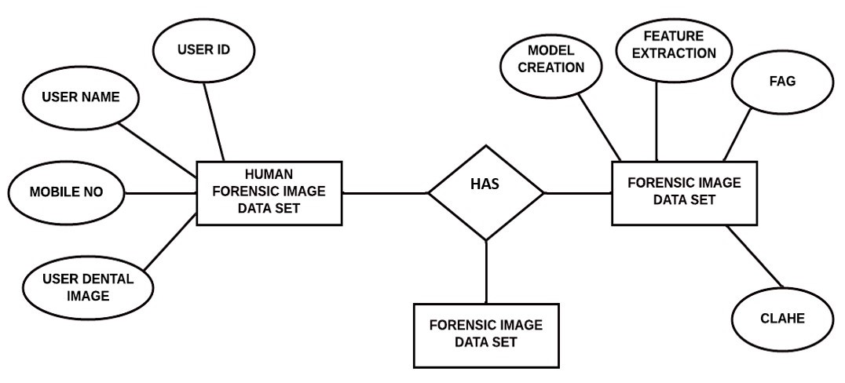
FIG.1.1 ER Diagram

4.2 DATA FLOW DIAGRAM
Data flow diagrams visually represent systems and processes that would be hard to describe through text. A DFD diagram represents the flow of a process in an easy and readable manner. The user shows the gestures in front of the camera. The nodes of the hand are detected using the mediapipe modules and it is compared with the gesture dictionary that is already processed. The gesture is then identified and the action is executed.

14

DFD LEVEL 0
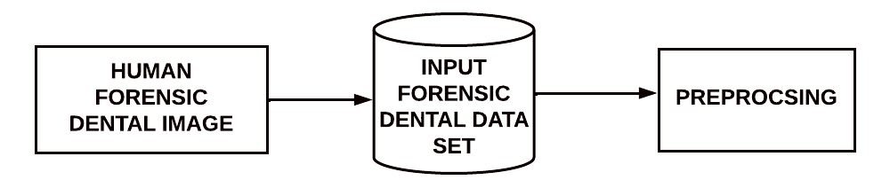
FIG 4.2.1-DFD Level 0

DFD LEVEL 1
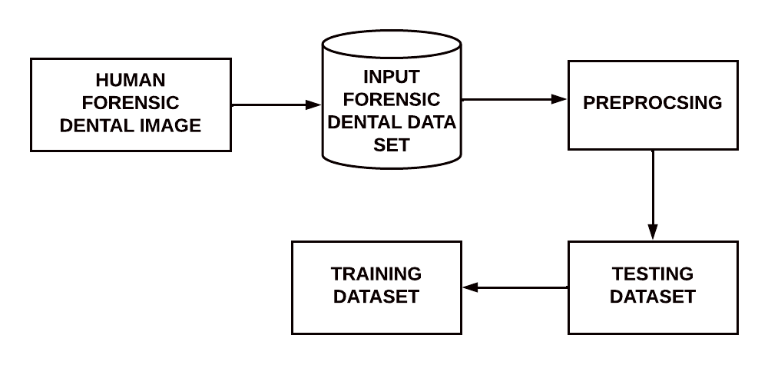
FIG 4.2.2-DFD Level 1

15
DFD LEVEL-2
-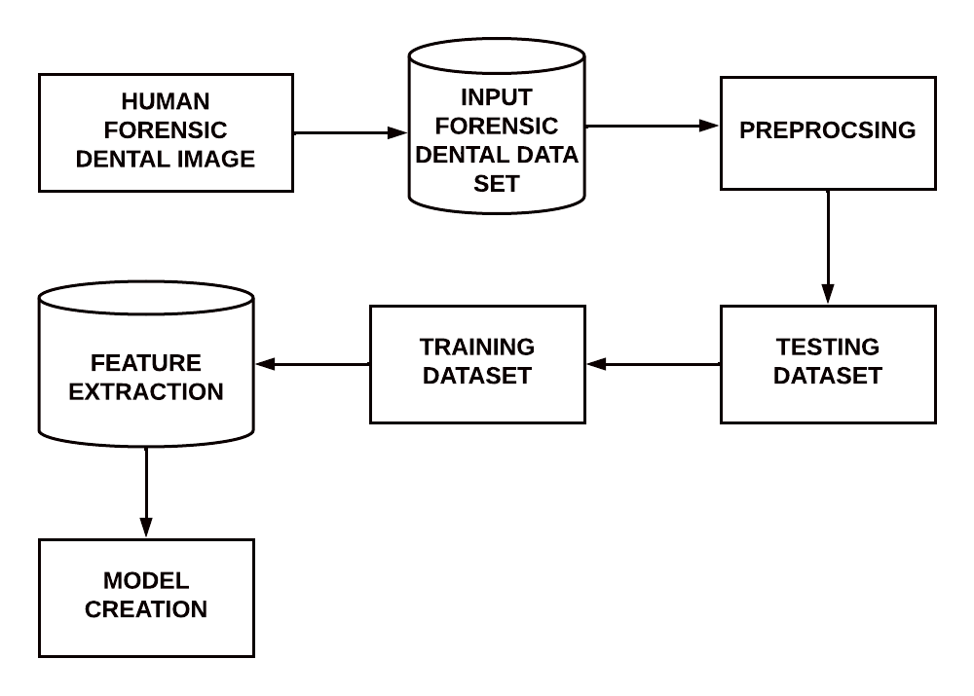
FIG 4.2.3-DFD Level 2
DFD LEVEL-3
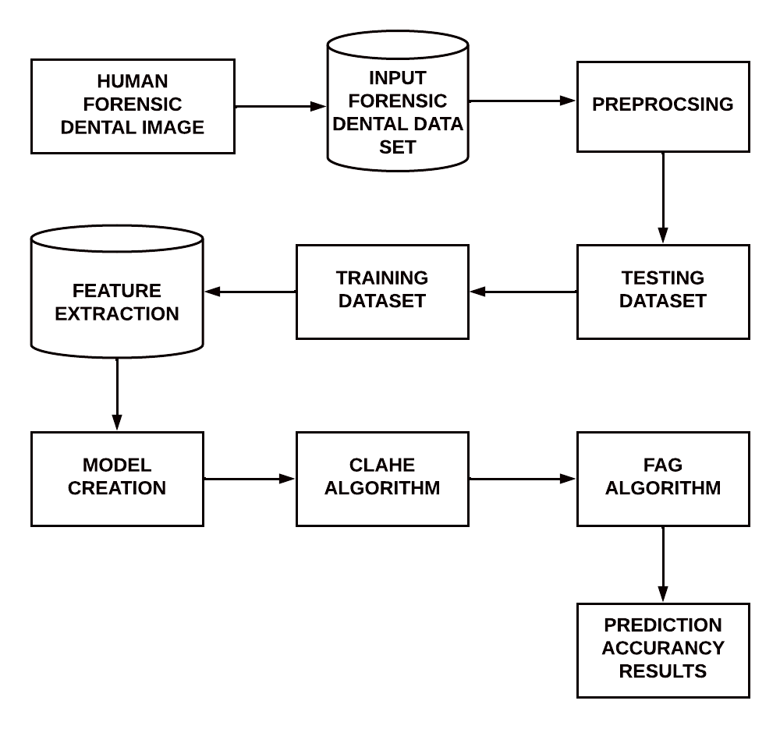
FIG 4.2.4-DFD Level 3
16

4.3 UML DIAGRAMS
4.3.1.USE CASE
A UML use case diagram form of system requirements for a new software program which is under development. Use case diagram specifies the expected behavior of making the software happen. Use cases once specified can be denoted both textual and visual representation (i.e. use case diagram). The main motive of a use case diagram is that it helps us design a system from the end user's perspective.

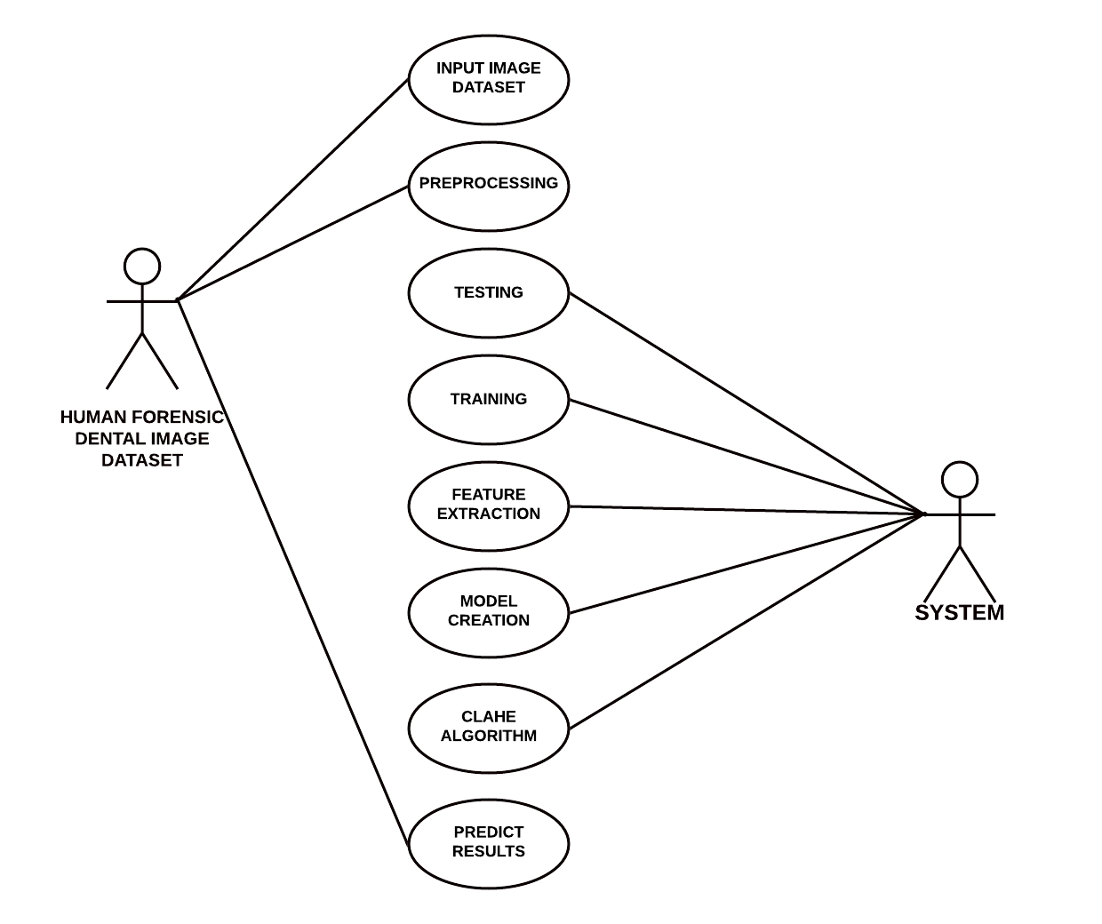
FIG 4.3.1-Usecase Diagram

17

4.3.2.CLASS DIAGRAM
Class diagram describes the attributes and operations of a class and also the constraints imposed on the system. It represents the static view of an application. It is also known as a structural diagram.In the above representation, there are five classes to demonstrate the virtual mouse. The corresponding methods are labelled in their respective classes.
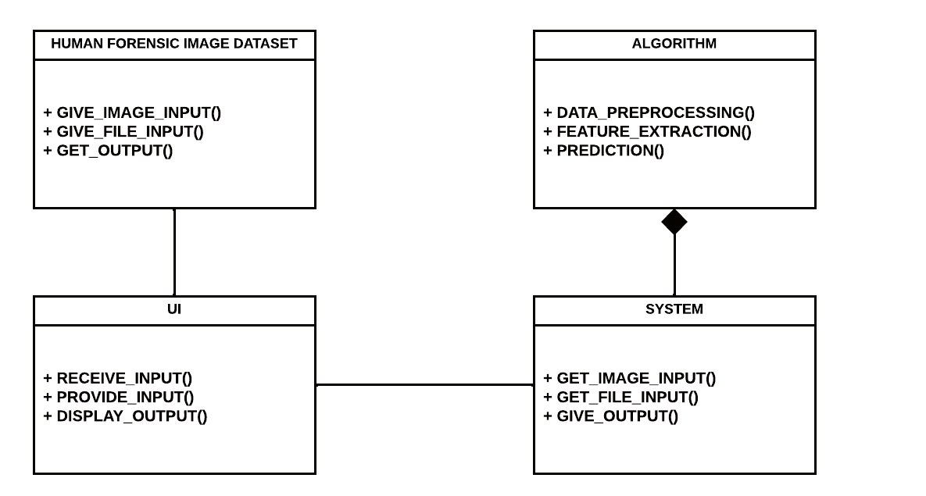
FIG 4.3.2-Class Diagram

18

4.3.3. SEQUENCE DIAGRAM
A sequence diagram or system sequence diagram (SSD) shows process interactions arranged in time sequence in the field of software engineering. It depicts the processes involved and the sequence of messages exchanged between the processes needed to carry out the functionality. Sequence diagrams are typically associated with use case realizations in the 4+1 architectural view model of the system under development. Sequence diagrams are sometimes called event diagrams
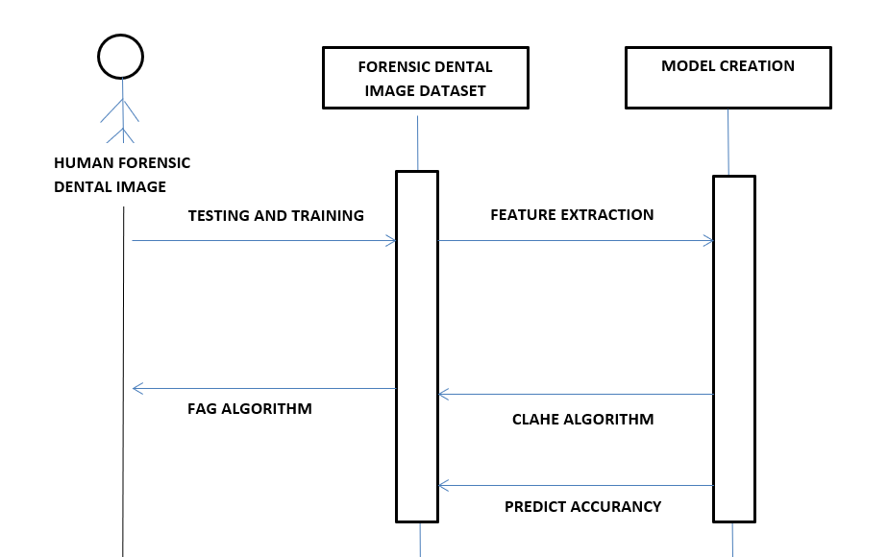

FIG 4.3.3-Sequence Diagram

19
4.3.4. ACTIVITY DIAGRAM
An activity diagram captures the dynamic behavior of the system. It portrays the control flow from a start point to a finish point showing the various decision paths that exist while the activity is being executed. The user gives the gestures as input through the webcam. The nodes of the hands are detected and compared with the predefined gestures and the necessary actions are executed. The input can also be given through the other module which is the voice assistant. In this module the input is given through voice commands.
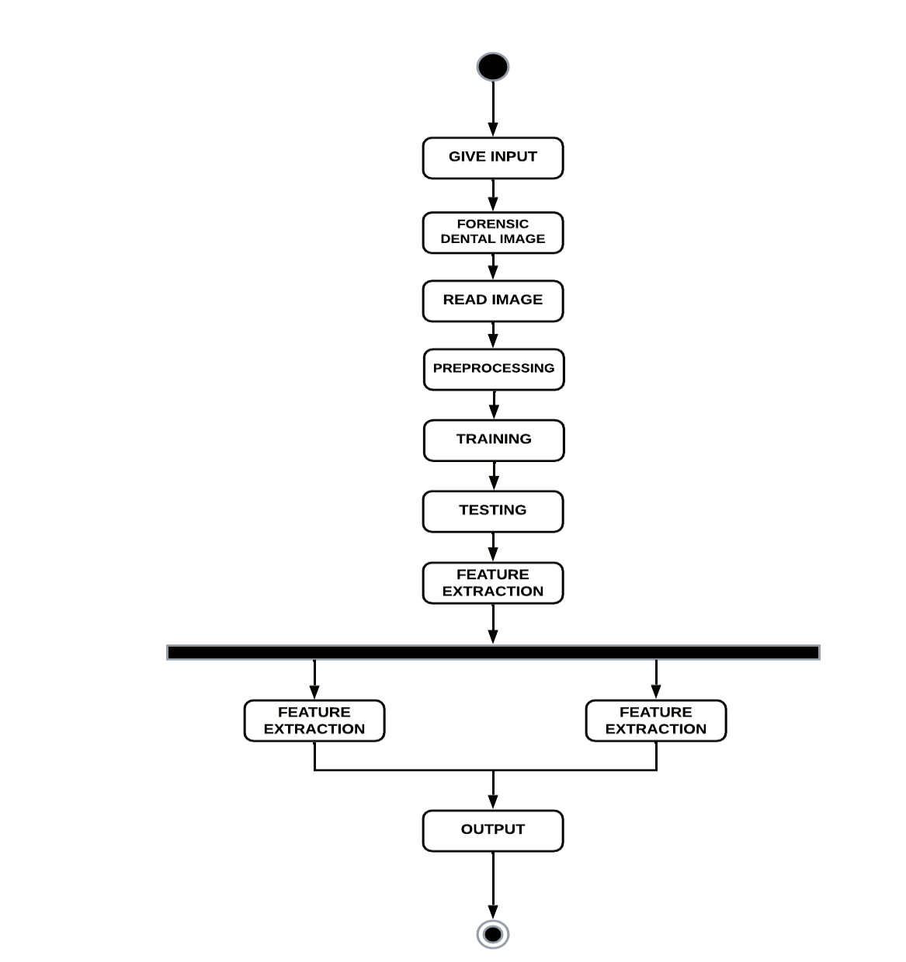
FIG 4.3.4-Activity Diagram

20
4.3.5. COMPONENT DIAGRAM
In Unified Modeling Language (UML)a component diagram depicts how components are wired together to form larger components or software systems. They are used to illustrate the structure of arbitrarily complex systems. A component diagram allows verification that a system's required functionality is acceptable. These diagrams are also used as a communication tool between the developer and stakeholders of the system. Programmers and developers use the diagrams to formalize a roadmap for the implementation, allowing for better decision-making about task assignment or needed skill improvements. System administrators can use component diagrams to plan ahead, using the view of the logical software components and their relationships on the system

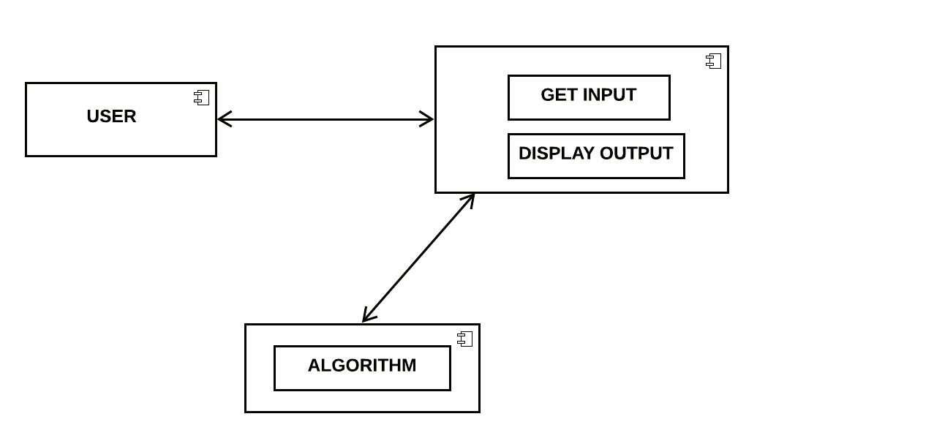
FIG 4.3.5-Component Diagram

21

CHAPTER 5
SYSTEM ARCHITECTURE

SYSTEM ARCHITECTURE
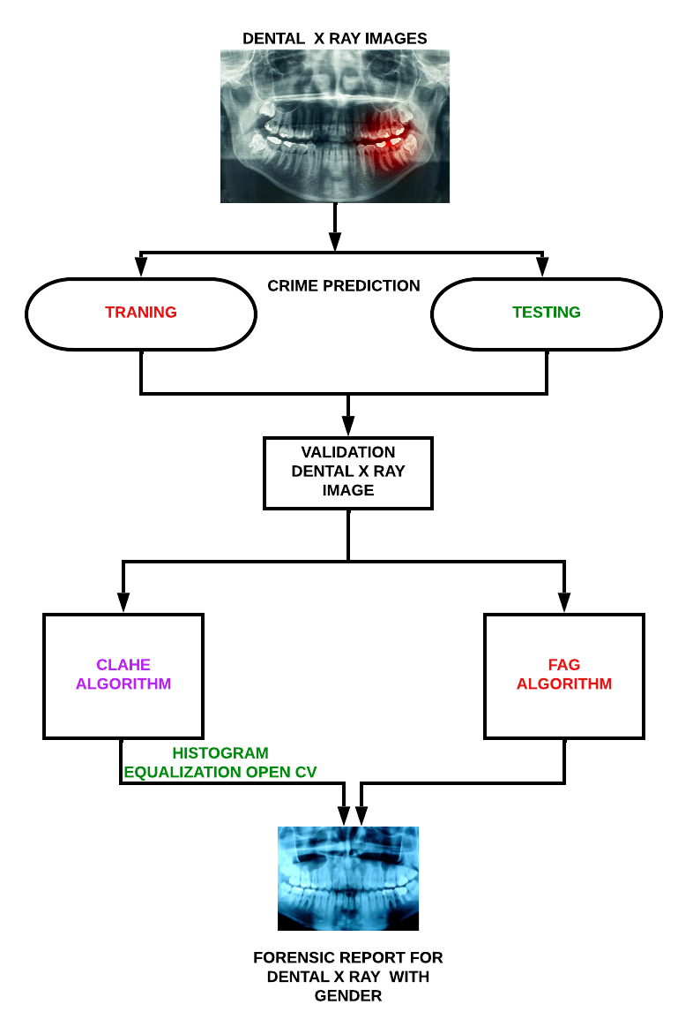FIG 5.1-System Architecture Diagram

5.1 MODULES, DESIGN AND SPECIFICATION LIST OF MODULES
- DATA GENERATION USING BALANCING IMAGE
- FORENSIC FREQUENCY PREDICTION BY CLAHE
- FORENSIC FREQUENCY PREDICTION USING DENTAL IMAGE
- LATENT PART LOCALIZATION
- CONTRASTIVE LEARNING WITH DSA

23
MODULES DESCRIPTION
- DATA GENERATION USING BALANCING IMAGE
A police-department demand for the preparation of this rhetorical prediction model is that it forecast residential felony over area and time. consequently, the model classifies burglaries monthly across a regular dental image. The dental image divides town into checkerboard-like cells. At intervals every cell, information is aggregate into dental rhetorical prediction. Every cell is inhabited on a monthly basis. The space is over one-quarter mile square. In each cases, every monthly information set may be a matrixes of six antecedently mentioned classes. The finer resolutions permits the dental image to be interrogated with lot of elaborate eye toward the spatial data inherent within the dataset. Conversely, the lower resolution has the impact of generalizing the spatial data. It ought to be noted that although this will increase the score of dental image classification, the general accuracy of the prediction is diminished attributable to the ensuing misclassification of cold spots. We have tendency to settle for the trade off on accuracy to own a better score on hotspots because the local department clearly encompasses a larger unconditional interest in knowing that a locality are a hotspot.Photo processing strategies including noise removal, observed through (low-level) function extraction to find lines, areas and probably regions with positive textures.Each quantity representing the brightness fee of the photograph at a specific place is referred to as a photograph element, or pixel. A usual digitized photograph might also additionally have 512 × 512 or more or less 250,000 pixels, even though a great deal large pix have become common. Once the photograph has been digitized, there are 3 simple operations that may be completed on it within side the laptop. For a factor operation, a pixel fee within side the output photograph relies upon on a unmarried pixel fee within side the enter photograph. For nearby operations, numerous neighboring pixels within side the enter photograph decide the fee of an output photograph pixel. In an international operation, all the enter photograph pixels make contributions to an output photograph pixel fee.

24
An instance is noise smoothing. To easy a loud photograph, median filtering may be carried out with a three × three pixel window. This manner that the fee of each pixel within the
noisy photograph is recorded, at the side of the values of its nearest 8 neighbours. These 9 numbers are then ordered consistent with length, and the median is chosen because the fee for the pixel within the new photograph. As the three × three window is moved one pixel at a time throughout the noisy photograph, the filtered photograph is formed.

2.FORENSIC FREQUENCY PREDICTION BY CLAHE
This experiment investigates the prediction of Forensic frequency by CLAHE algorithm. The procedure used in the experiment, outlining the four middle steps of the CLAHE algorithm methodology data understanding, data preparation, modeling and evaluation. The first stage in the Data Understanding step was to integrate the data into one dataset by aggregating the monthly files. All experiments started with this dataset. For the purpose of this experiment, the frequency per month, per CLAHE algorithm, for each Forensic type was computed an instance represents the frequency of Forensic for a particular month, CLAHE algorithm and Forensic type. This aggregation meant that some of the attributes that were relevant for individual Forensic became irrelevant for a monthly record of Forensic frequency. These attributes are: Forensic ID, age, father name, Forensic details in the dataset for this experiment included attributes: The instances from the original dataset that had missing values for CLAHE algorithm name were excluded. In Deep learning, classification is that the downside of characteristic to that of a collection of classes a brand new observation belongs, on the premise of a coaching set of information containing observations whose class membership is thought. supported the feature choice that is finished before classification.

25

- FORENSIC FREQUENCY PREDICTION USING DENTAL IMAGE
The only difference is the addition of the dental Forensic prediction attribute; an instance represents the frequency of Forensic in a particular month, for a particular FAG algorithm and postcode, and for a particular Forensic type. To find the correspondence between FAG algorithm and postcodes, the Office for National Statistics was used, which has a databases of dental images listing postcodes and their different output areas, including FAG algorithm. This dental image database is from 2011. The lower number of data objects in this dataset compared with the FAG algorithm is due to the information on the equivalence between the CLAHE and FAG algorithm. Generally, postcodes areas cover several FAG algorithms, thus capturing information at a different geographical level which could potentially improve predictions. In terms of the performance of the algorithm CLAHE and FAG algorithm have medium correlation coefficients, while the M5P algorithm has a strong correlation coefficient between the values predicted by the model and the real values.
Once the information is pre-processed, the feature extraction takes place wherever from the audio wave signal obtained, LSTM dense, dropout, activation layers square measure extracted from higher and lower dimensions. In Activation, ReLu operate is another non-linear activation operate that has gained quality within the deep learning domain. ReLU stands for corrected linear measure. the most advantage of victimization the ReLU operate over alternative activation functions is that it doesn't activate all the neurons at an equivalent time. Finally, of these extracted layers square measure fed into a model and therefore the model is organized for coaching. The model is compiled with parameters referred to as loss, optimizers and metrics. Categorical crossentropy loss operate is employed here with Adam optimizer and accuracy metrics. At last, the compiled model is came to be utilized in the algorithmic program.

26

- LATENT PART LOCALIZATION
Dental image rhetorical prediction elements square measure vital personally rhetorical. The explored rigid body elements to develop strong options. However, because of the dissatisfactory pedestrian detection algorithms and huge dental variations, the tactics of exploitation rigid body elements for native feature learning isn't the best answer. once exploitation rigid body elements, the highest half consists of enormous quantity of background. This motivates United States to be told and localize the pedestrian elements mechanically. we have a tendency to integrate CLAHE and FAG formula because the half localization internet in our projected model. The initial CLAHE is projected to expressly learn the image transformations parameters, like translation and scale. it's two main advantages: (1) it's absolutely differentiable will|and may|and might} be simply integrated into existing deep learning frameworks (2) it can learn to translate, scale and crop or warp a noteworthy regions while not to express region annotation. These facts create it terribly appropriate for pedestrian elements localization.
- CONTRASTIVE LEARNING WITH DSA
We hand out FoID by 1st describing its building elements then the multi-task learning strategy. FoID maps every scan instances into associate degree embedding. Given a question instance, we tend to calculate the similarities between the question and every one the gallery instances within the embedding house and come back the graded retrieval list. to attain effective illustration learning, augmentations that cowl the potential anatomical variations as in clinics is that the key. The planned DSA consists four kinds of parameters impressed by rhetorical observations, and is severally applied to every attention patch on the fly.
(i) Random tooth reduction that aims to simulate tooth loss caused by injury or inventions (ii) Random physical object addition that adds patches of versatile shapes to crown or tooth regions such augmentation aims to simulate the common artifacts of dental filling, implant, and brace.
27
(iii) Random rigid patch rework at intervals a spread of angles and displacements. The augmentation not solely enforces read comparison as within the commonplace instance discrimination learning, however conjointly simulates world teeth arrangement changes, since the rework is performed for patches severally.
(iv) Random colour disturbance of distinction shifting and Gaussian noise at intervals designed ranges for simulating totally different scanning setup and machine noises. additional details concerning the implementation of DSA area unit enclosed.
5.2. ALGORITHM
5.2.1. Contrast Limited Adaptive Histogram Equalization (CLAHE)
Contrast restricted adaptational bar graph leveling (CLAHE) algorithmic program was used because the initial technique for enhancing the distinction between veins and also the background. The careful step of the CLAHE algorithms square measure explained as follows. Image is rotten into variety of continuous and non-overlapping discourse regions. A bar graph for every of those discourse regions is computed. Clip limit could be a threshold parameter for effectively sterilisation the distinction of the image. Thus, associate degree applicable price of clip limit is set supported trial-and-error to extend the native image regions. The bar graph of every discourse region is clipped on top of the brink. The transformation perform for every clipped bar graph is applied to perform equalize greyscale mapping. The mathematical expression for remodel intensity price into uniform distribution is given as
g = [gmax − gmin] ∗ P(f) + gmin
where gmax is maximum pixel value,
gmax is minimum pixel value,
g is computed pixel value,
P(f) is a cumulative probability distribution.
The neighboring regions are combined using bilinear interpolation to create an enhanced image without artificially induced boundary

28
5.2.2 Fuzzy Adaptive Gamma (FAG)
The fuzzy reconciling gamma (FAG) algorithmic rule was used because the second technique to boost the distinction between veins and also the background. The planned FAG image sweetening involves 3 stages: fuzzification, modification of membership values, and defuzzification.
Fuzzification: Fuzzification may be a step to see the degree to that computer file belongs to every of the suitable fuzzy sets via the membership operate. Hence, this work involves changing greyscale worths of dorsal hand vein image as AN input to the fuzzy domain whose value ranges between zero and one employing a linear operate. The linear operate is expressed as
Iout = I in − Imin Imax − Imin
where I in is the image of the dorsal hand vein,
I out is the dorsal hand vein image in the fuzzy domain,
Imin is the minimum value of the gray-level and
Imax is the maximum value of the gray level in the image.

29

CHAPTER 6
SYSTEM IMPLEMENTATION

SYSTEM IMPLEMENTATION
6.1CODING
import tensorflow as tf
from keras.preprocessing.image import ImageDataGenerator
from keras.preprocessing import image
from CNN import cnn_predict
from popwindow import popupmsg
import cv2
import numpy as np
import easygui
import os
import serial
#import requests
import sys
from PIL import Image
print(tf.__version__)
#url='http://iotbegineer.com/api/sensors'
#feature training
train_datagen = ImageDataGenerator(
# reducing/normalizing the pixels
rescale=1./255,
shear_range=0.2,
zoom_range=0.2,
horizontal_flip=True)
#connecting the image augmentation tool to our dataset
train_set = train_datagen.flow_from_directory(
'training_set',
#final size of the images that will be fed into the ann
target_size=(128, 128),
31
batch_size=32,
# we have binary classification --> binary class mode
class_mode='binary')
#only rescaling but no transformations
test_datagen = ImageDataGenerator(rescale=1./255)
#connecting to the test data
test_set = test_datagen.flow_from_directory(
'test_set',
target_size=(128, 128),
batch_size=32,
class_mode='binary')
print(test_set)
#--------------------- Building CNN --------------------#
# initializing CNN as sequential layers
cnn = tf.keras.models.Sequential()
# Step 1: Convolution to get the Feature Map
cnn.add(tf.keras.layers.Conv2D(filters = 32, kernel_size = 3, activation = 'relu', input_shape=[128,128,3]))
# Step 2: Max Pooling
cnn.add(tf.keras.layers.MaxPool2D(pool_size=6 ,strides=7))
#adding a second convolutional layer
cnn.add(tf.keras.layers.Conv2D(filters = 32, kernel_size = 3, activation = 'relu'))
cnn.add(tf.keras.layers.MaxPool2D(pool_size=6 ,strides=7))
# Step 3: Flattening
cnn.add(tf.keras.layers.Flatten())
#Step 4: Full Connection
cnn.add(tf.keras.layers.Dense(units = 128, activation = 'relu'))
# Step 5: Output Layer
cnn.add(tf.keras.layers.Dense(units = 1, activation = 'sigmoid'))
32
#--------------------- Training the CNN --------------------#
#compiling the CNN
cnn.compile(optimizer = 'adam', loss = 'binary_crossentropy', metrics = ['accuracy'])
#training the CNN on the training set and evaluating it on the test set
cnn.fit(x = train_set, validation_data = test_set, epochs = 5)
# Testing
#im1 = sys.argv[1]
image11 = easygui.fileopenbox()
result1=image11
#test_image2 = image.load_img(image11, target_size = (128, 128))
#test_image2 = image.img_to_array(test_image2)
#test_image2 = np.expand_dims(test_image2, axis = 0)
#cnn prediction on the test image
#result2 = cnn.predict(test_image2)
#print(cnn.predict(test_image2))
predict=cnn_predict(result1,1)
print("Result: ",predict)
popupmsg(predict,"RESULT")
import tensorflow as tf
from keras.preprocessing.image import ImageDataGenerator
from keras.preprocessing import image
from CNN import cnn_predict
from popwindow import popupmsg
import cv2
import numpy as np
import easygui
import os
import serial
#import requests
33
import sys
from PIL import Image
print(tf.__version__)
#url='http://iotbegineer.com/api/sensors'
#feature training
train_datagen = ImageDataGenerator(
# reducing/normalizing the pixels
rescale=1./255,
shear_range=0.2,
zoom_range=0.2,
horizontal_flip=True)
#connecting the image augmentation tool to our dataset
train_set = train_datagen.flow_from_directory(
'training_set',
#final size of the images that will be fed into the ann
target_size=(128, 128),
# number of images that we want to have in each batch
batch_size=32,
# we have binary classification --> binary class mode
class_mode='binary')
#only rescaling but no transformations
test_datagen = ImageDataGenerator(rescale=1./255)
#connecting to the test data
test_set = test_datagen.flow_from_directory(
'test_set',
target_size=(128, 128),
batch_size=32,
class_mode='binary')
print(test_set)
34
#--------------------- Building CNN --------------------#
# initializing CNN as sequential layers
cnn = tf.keras.models.Sequential()
# Step 1: Convolution to get the Feature Map
cnn.add(tf.keras.layers.Conv2D(filters = 32, kernel_size = 3, activation = 'relu', input_shape=[128,128,3]))
# Step 2: Max Pooling
cnn.add(tf.keras.layers.MaxPool2D(pool_size=6 ,strides=7))
#adding a second convolutional layer
cnn.add(tf.keras.layers.Conv2D(filters = 32, kernel_size = 3, activation = 'relu'))
cnn.add(tf.keras.layers.MaxPool2D(pool_size=6 ,strides=7))
# Step 3: Flattening
cnn.add(tf.keras.layers.Flatten())
# Step 4: Full Connection
cnn.add(tf.keras.layers.Dense(units = 128, activation = 'relu'))
# Step 5: Output Layer
cnn.add(tf.keras.layers.Dense(units = 1, activation = 'sigmoid'))
#--------------------- Training the CNN --------------------#
#compiling the CNN
cnn.compile(optimizer = 'adam', loss = 'binary_crossentropy', metrics = ['accuracy'])
#training the CNN on the training set and evaluating it on the test set
cnn.fit(x = train_set, validation_data = test_set, epochs = 5)
# Testing
#im1 = sys.argv[1]
image11 = easygui.fileopenbox()
result1=image11
#test_image2 = image.load_img(image11, target_size = (128, 128))
#test_image2 = image.img_to_array(test_image2)
#test_image2 = np.expand_dims(test_image2, axis = 0)
#cnn prediction on the test image
#result2 = cnn.predict(test_image2)
#print(cnn.predict(test_image2))
predict=cnn_predict(result1,1)
print("Result: ",predict)
popupmsg(predict,"RESULT")
app.py
----------------------------------------------
from flask import Flask, flash, request, redirect, url_for, render_template
from werkzeug.utils import secure_filename
from tensorflow.keras.models import load_model
import numpy as np
import os
35
import cv2
import ntpath
from clahe import clahe_prediction
# Creating a Flask Instance
app = Flask(__name__)
IMAGE_SIZE = (150, 150)
UPLOAD_FOLDER = 'static\\uploads'
ALLOWED_EXTENSIONS = set(['png', 'jpg', 'jpeg'])
app.config.from_object(__name__)
app.config['SECRET_KEY'] = '7d441f27d441f27567d441f2b6176a'
app.config['UPLOAD_FOLDER'] = UPLOAD_FOLDER
print("Loading Pre-trained Model ...")
def image_preprocessor(path):
'''
Function to pre-process the image before feeding to model.
'''
print('Processing Image ...')
currImg_BGR = cv2.imread(path)
b, g, r = cv2.split(currImg_BGR)
currImg_RGB = cv2.merge([r, g, b])
currImg = cv2.resize(currImg_RGB, IMAGE_SIZE)
currImg = currImg/255.0
currImg = np.reshape(currImg, (1, 150, 150, 3))
return currImg
def model_pred(image,filename):
Perfroms predictions based on input image
print("Image_shape", image.shape)
print("Image_dimension", image.ndim)
prediction=clahe_prediction(filename)
#return (int(prediction))
# Returns Probability:
# prediction = model.predict(image)[0]
# Returns class:
#prediction = model.predict_classes(image)[0]
if prediction == 0:
return "NORMAL"
return (prediction)
def allowed_file(filename):
return '.' in filename and \
filename.rsplit('.', 1)[1].lower() in ALLOWED_EXTENSIONS
@app.route('/', methods=['GET', 'POST'])
def home():
return render_template('index.html')
36
@app.route('/upload', methods=['GET', 'POST'])
def upload_file():
# Checks if post request was submitted
if request.method == 'POST':
- request.url - http://127.0.0.1:5000/
- request.files - Dictionaary of HTML elem "name" attribute and corrospondiong file details eg.
"imageFile" : <FileStorage: 'Profile_Pic.jpg' ('image/jpeg')>
# check if the post request has the file part
if 'imageFile' not in request.files:
flash('No file part')
return redirect(request.url)
# check if filename is an empty string
file = request.files['imageFile']
if file.filename == '':
flash('No selected file')
return redirect(request.url)
# if file is uploaded
if file and allowed_file(file.filename):
filename = secure_filename(file.filename)
38
imgPath = os.path.join(app.config['UPLOAD_FOLDER'], filename)
file.save(imgPath)
print("Image saved at {imgPath}",imgPath)
# Preprocessing Image
image = image_preprocessor(imgPath)
# Perfroming Prediction
pred = model_pred(image,filename)
return render_template('upload.html', name=filename, result=pred)
return redirect(url_for('home'))
if __name__ == '__main__':
app.run(debug=True)
clahe
import numpy as np
import imageio
import matplotlib.pyplot as plt
import os
import timeit
from collections import Counter
def clahe_prediction(filename):
37
def CLAHE(BaseAlgorithm):
'''Contrast Limited Adaptive Histogram Equalization.
In reality, we do a normalization before applying CLAHE, making it the N-CLAHE method, but in
N-CLAHE the normalization is done using a log function, instead of a linear one, as we use here.
def __init__(self, filename, results_path):
self.filename = filename
self.results_path = results_path
self.get_input()
def run(self):
image = imageio.imread(self.filenam
if len(image.shape) > 2:
image = pu.to_grayscale(image)
normalized_image = pu.normalize(np.min(image), np.max(image), 0, 255, image)
imageio.imwrite(os.path.join(self.results_path, "normalized_image.jpg"), normalized_image)
start = timeit.default_timer()
equalized_image = self.clahe(normalized_image)
stop = timeit.default_timer()
self.export_histogram(image, normalized_image, equalized_image)
self.export_run_info(stop - start)
return equalized_image
def get_input(self):
print("Window size: ")
self.window_size = int(input())
print("Clip limit: ")
self.clip_limit = int(input())
print("Number of iterations: ")
self.n_iter = int(input())
def clahe(self, image):
'''Applies the CLAHE algorithm in an image.
Parameters:
image: image to be processed
Returns a processed image.
border = self.window_size //
padded_image = np.pad(image, border, "reflect")
shape = padded_image.shape
padded_equalized_image = np.zeros(shape).astype(np.uint8)
for i in range(border, shape[0] - border):
if i % 50 == 0:
print(f"Line: {i}")
for j in range(border, shape[1] - border):
38
# Removing the padding from the image
equalized_image = padded_equalized_image[border:shape[0] - border, border:shape[1] - border].astype(np.uint8)
return equalized_image
def clipped_histogram_equalization(self, region):
40'
''Calculates the clipped histogram equalization for the given region.
Parameters:
region: array-like.
Returns a dictionary with the CDF for each pixel in the region.
# Building the histogram
hist, bins = pu.histogram(region)
n_bins = len(bins)
# Removing values above clip_limit
excess = 0
for i in range(n_bins):
if hist[i] > self.clip_limit:
excess += hist[i] - self.clip_limit
hist[i] = self.clip_limit
## Redistributing exceding values ##
# Calculating the values to be put on all bins
for_each_bin = excess // n_bins
# Calculating the values left
leftover = excess % n_bins
hist += for_each_bin
for i in range(leftover):
hist[i] += 1
# Calculating probability for each pixel
pixel_probability = hist / hist.sum()
# Calculating the CDF (Cumulative Distribution Function)
cdf = np.cumsum(pixel_probability)
cdf_normalized = cdf * 255
hist_eq = {}
for i in range(len(cdf)):
hist_eq[bins[i]] = int(cdf_normalized[i])
return hist_eq
def export_histogram(self, image, normalized, equalized):
plt.xlabel("Pixel")
plt.ylabel("Count")
hist, bins = pu.histogram(image)
39
plt.plot(bins, hist, label='Original Image'
plt.legend()
hist, bins = pu.histogram(normalized)
plt.plot(bins, hist, label='Normalized Image')
plt.legend()
hist, bins = pu.histogram(equalized)
plt.plot(bins, hist, label='CLAHE Result')
plt.legend()
plt.savefig(os.path.join(self.results_path, "histograms.jpg"))
def export_run_info(self, runtime):
with open(os.path.join(self.results_path, "runinfo.txt"), 'w+') as f:
f.write(f"Runtime: {runtime:.2f}s\n")
f.write(f"Window size: {self.window_size}\n")

40

CHAPTE 7

SYSTEM TESTING

SYTEM TESTING
Unit Testing
In the lines of strategy, all the individual functions and modules were put to the test independently. By following this strategy all the errors in coding were identified and corrected. This method was applied in combination with the White and Black Box testing Techniques to find the errors in each module.
Integration Testing
Data can be lost across the interface; one module can have an adverse effect on others. Integration testing is a systematic testing for constructing program structure. While at the same time conducting tests to uncover errors associated within the interface. Integration testing addresses the issues associated with the dual problems of verification and program construction. After the software has been integrated a set of high order sets and conducted.
The objective is to take unit tested modules and combine them test it as a whole. Thus, in the integration-testing step all the errors uncovered are corrected for the next testing steps.
Validation Testing
The outputs that come out of the system are as a result of the inputs that go into the system. The correct and the expected outputs that go into the system should be correct and proper. So this testing is done to check if the inputs are correct and they are validated before it goes into the system for processing.
Acceptance Testing
User acceptance of a system is the key factor for the success of any system. The system under consideration is tested for the user acceptance by constantly keeping in touch with the prospective system users at the time of developing and making changes whenever required. This is done in regard to the following point:
- Input screen design
- Output screen design
An acceptance test has the objective of selling the user on the validity and reliability of the system. It verifies that the system’s procedures operate to system specifications and that the integrity of important data is maintained.
42
7.1 TEST CASE & REPORT

- LOGIN
S.NO | ACTION TO PERFORM | EXCEPTED RESULT | ACTUAL RESULT | RESULT(  PASS/FAIL)
1. | RUN | Run the code | As Excepted | Pass
2. | Copy | Copy the web portal address | As Excepted | Pass
3. | Paste | Paste the copied web portal address in web page and click enter | As Excepted | Pass
4. | Home page | Connect to the web | As Excepted | Pass

43

2.UPLOAD FILE

S.NO | ACTION TO PERFORM | EXCEPTED RESULT | ACTUAL RESULT | RESULT(  PASS/FAIL)
1. | Upload | After connecting, click on upload file | As Excepted | Pass
2. | File | Choose a file to be uploaded | As Excepted | Pass
3. | Submit | After the completion of uploading, click on submit. | As Excepted | Pass

44

CHAPTER 8
CONCLUSION

8.1 CONCLUSION

Now a day’s rhetorical dental image dataset prediction. rhetorical dental is an element of human activities and desires to be managed. No human society has ever been entirely freed from deviants and it's unlikely that society can ever be. This application is created to figure proficiently and viably. It leads to customary and auspicious activity against wrong doing careful. It tends to be seen that the image information set is nonheritable effortlessly and exactly.It ought to likewise lay the higher correspondence, decreasing wrongdoing and whole operating less tedious.By utilizing these application individuals who are apprehensive have enough time to go forensic dental image dataset for grievances about their own legitimate issues, or any sort of issues, here they can give their dissensions through forensic to enlist any kind of protests

8.2 FUTURE ENHANCEMENT

Segmenting teeth in dental X-ray pictures has been pursuit for several years, primarily relying in unsupervised strategies. though several approaches were projected and tested, triple-crown results were still aloof from being reached. Segmenting tooth in buckle pictures is necessary for additional advanced tasks in call support systems. this can be the primary step to sight not solely teeth and their rhetorical dental image dataset even missing teeth. Considering that our projected deep learning system incontestable promising results on a difficult knowledge set, resides on the instance segmentation of every component of the teeth, likewise as detection of missing teeth, of these with the goal of mechanically generating medical reports

46

APPENDICES

A1.SAMPLE SCREENSHOTS
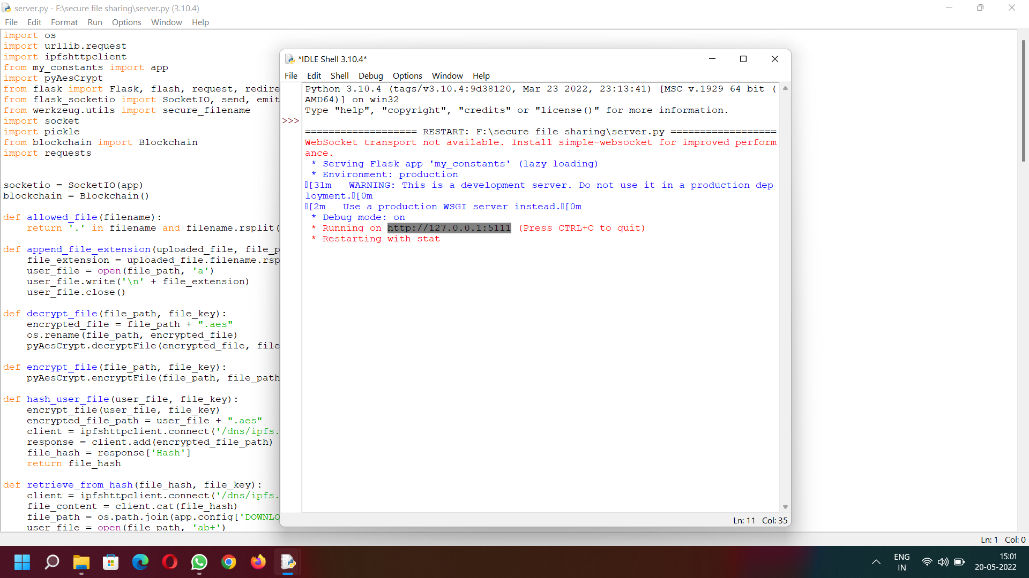
A.1 Run To Execute
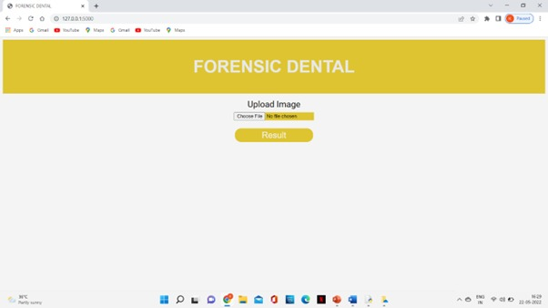
A.2 Home Page

48
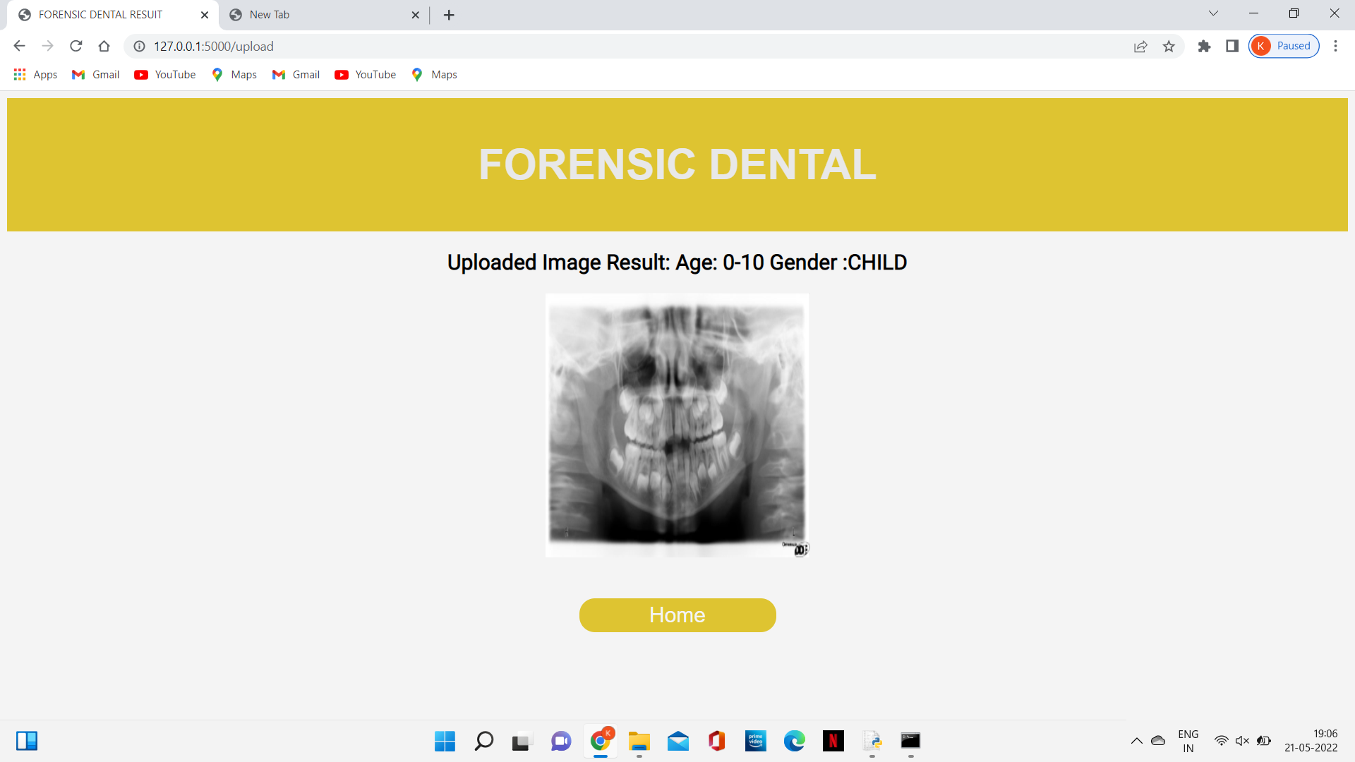

FIG A.2 Prediction Page

49
REFERENCES

[1] Zhivuan Zhang, Xin Zhong(2020), “3D Dental Biometrics Automatic Pose-invariant Dental Arch Extraction and Matching”
[2] Jingxuan Bao, Mansu Kim, Qing Sun, Anderson T. Hara , Gerardo Maupome and Li Shenk(2020),” Estimating Hard-tissue Conditions from Dental Images via Machine Learning”
[3]Mohamed Heshem , Monis Luquman Mohamed, Ahmed E. Youssef(2020),” Improving the Efficiency of Dental Implantation Process Using Guided Local Search Models and Continuous Time Neural Networks With Robotic Assistance”
[4] S. Sivagami, P. Chitra, G. Sri Ram Kailash, and S.R. Muralidharan(2020),” UNet Architecture Based Dental Panoramic Image Segmentation”’
[5] Sindu Divakaran, K. Vasanth, Suja D, Swedha V(2021),” Classification of Digital Dental X-ray Images Using Machine Learning”
[6] Dhruv Verma , Dr Sunaina Puri , Dr Srikanth Prabhu and Dr Komal Smriti(2021),” Anomaly detection in panoramic dental x-rays using a hybrid Deep Learning and Machine Learning approach”
[7] G.jaffino, A.Banumathi, j.prabin jose(2021),” Dental work extraction for different radiographic Images in human Forensic Identification”
[8] Anil Gurses, Ayse betul oktay(2021),” Tooth Restoration and Dental Work Detection on Panoramic Dental Images via CNN”
[9] Danijela Kalibovic Govorko, Benjamin Benzon, Katarina(2021),” Conventional vs. Digital dental impression: practitioner’s and patient’s perspective-a pilot study”
[10] Tomoko yui, Tomoki Ishikura, SungGwi Cho(2021),” : A Quantitative Measurement of Hand Scaling Motion for Dental Hygienist Training”

50

